

|  |  |  |  |  |  |
| --- | --- | --- | --- | --- | --- |
| Programme | : | **M.Tech. (Integrated) Software Engineering** | Semester | : | **Fall 20-21** |
| Course | : | **Advanced Database Management Systems** | Code | : | **SWE2014** |
| Faculty | : | **Dr.Bhuvaneswari A** | Slot | : | **L27 + L28** |
| Date | : | **14-07-2020** | Marks | : | **2.5 Points** |
|  |  |  |  |  |  |

NAME: K. NAVEEN KUMAR

REGNO : 17MIS1056

**Exercise 1: SQL BASIC Introduction DDL & DML**

i) Create table “Student” with the attributes RegNumber (Number), StudName (Character), Department (Character), ContactNumber (Number with 10 digits maximum), Date of Birth (Date), Location (Character), CGPA (2 digits maximum with 2 digits to the right of the decimal place.)

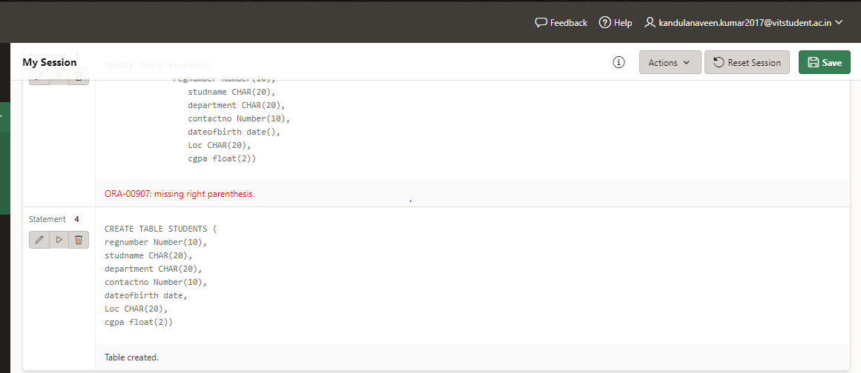

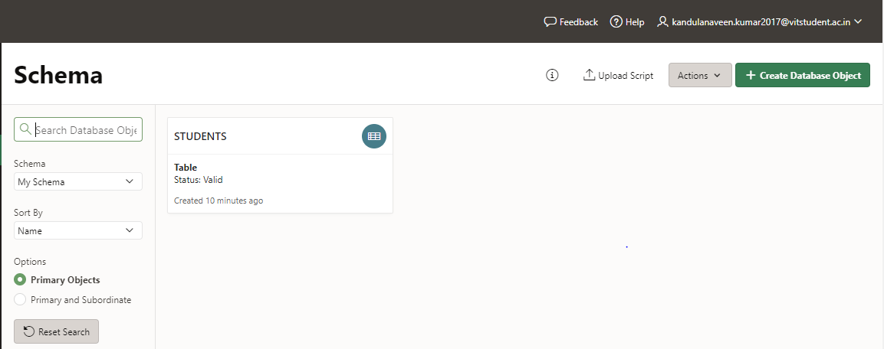

ii) Display the structure of the table (Use Desc command)

iii) Add new Column “Age” into the table.

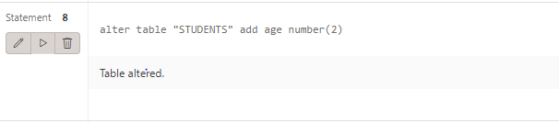

iv) Insert 7 values into the table.

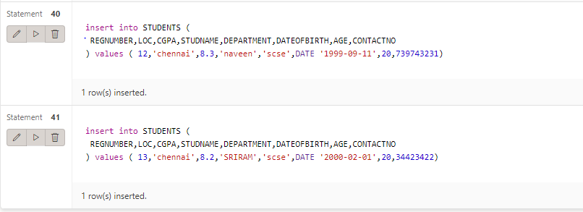

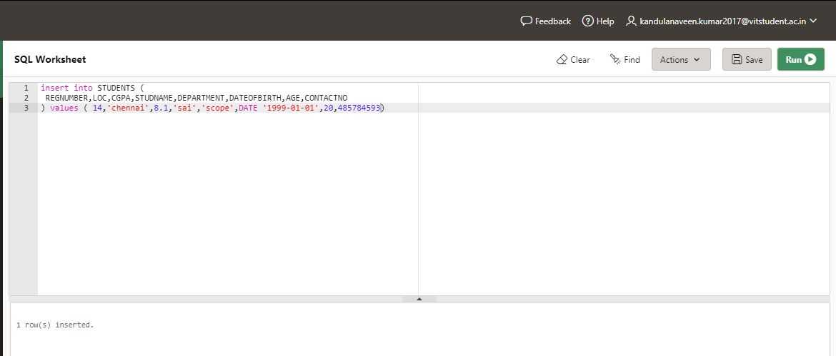

v) Rename the ContactNumber attribute as MobileNo.

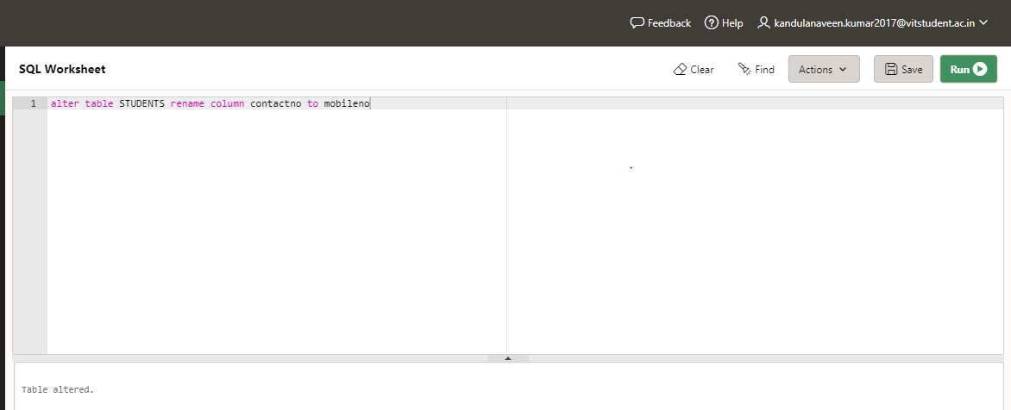

vi) Display the table with all attributes.

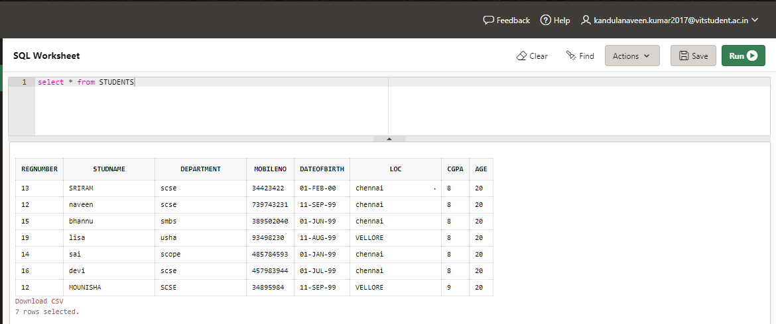

vii) Display the students who studies in ‘SCSE’.

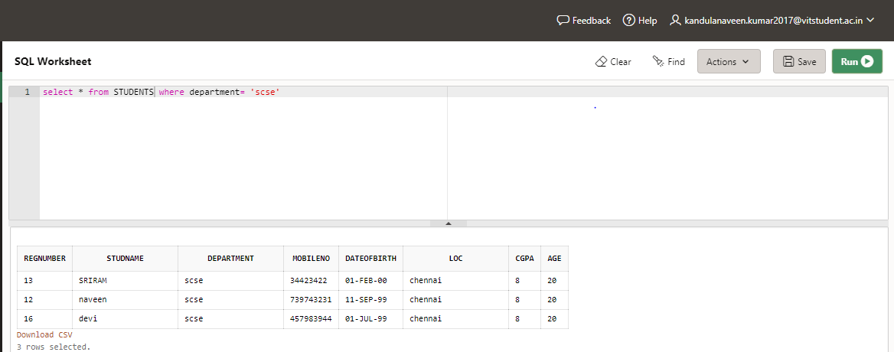

viii) Delete the records of student whose Location is “Chennai”

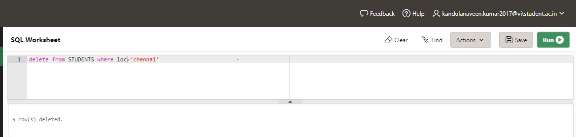

ix) Modify the table by removing Location attribute.

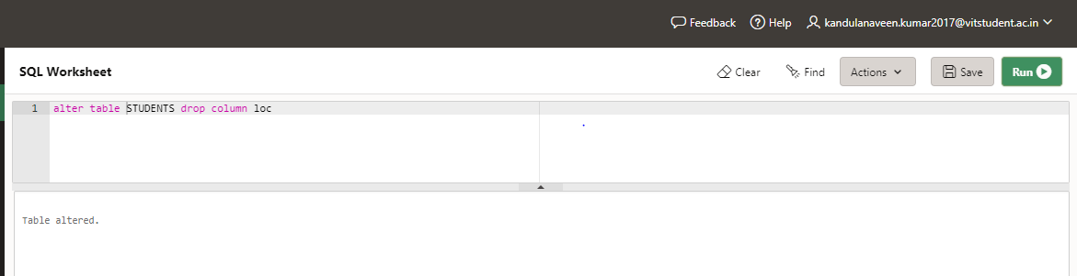

x) Truncate the student table.

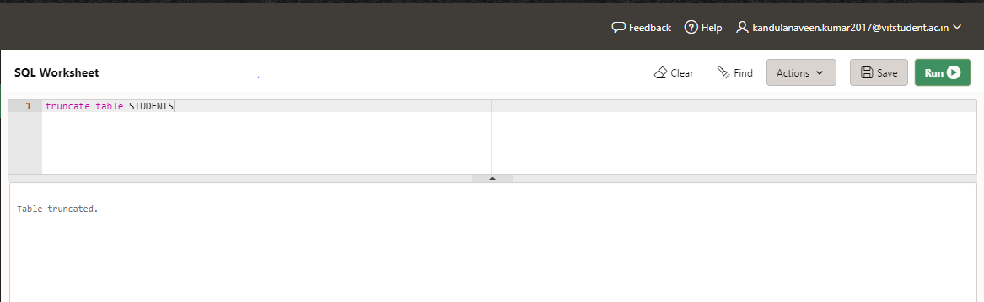

xi) Drop the table Student.

